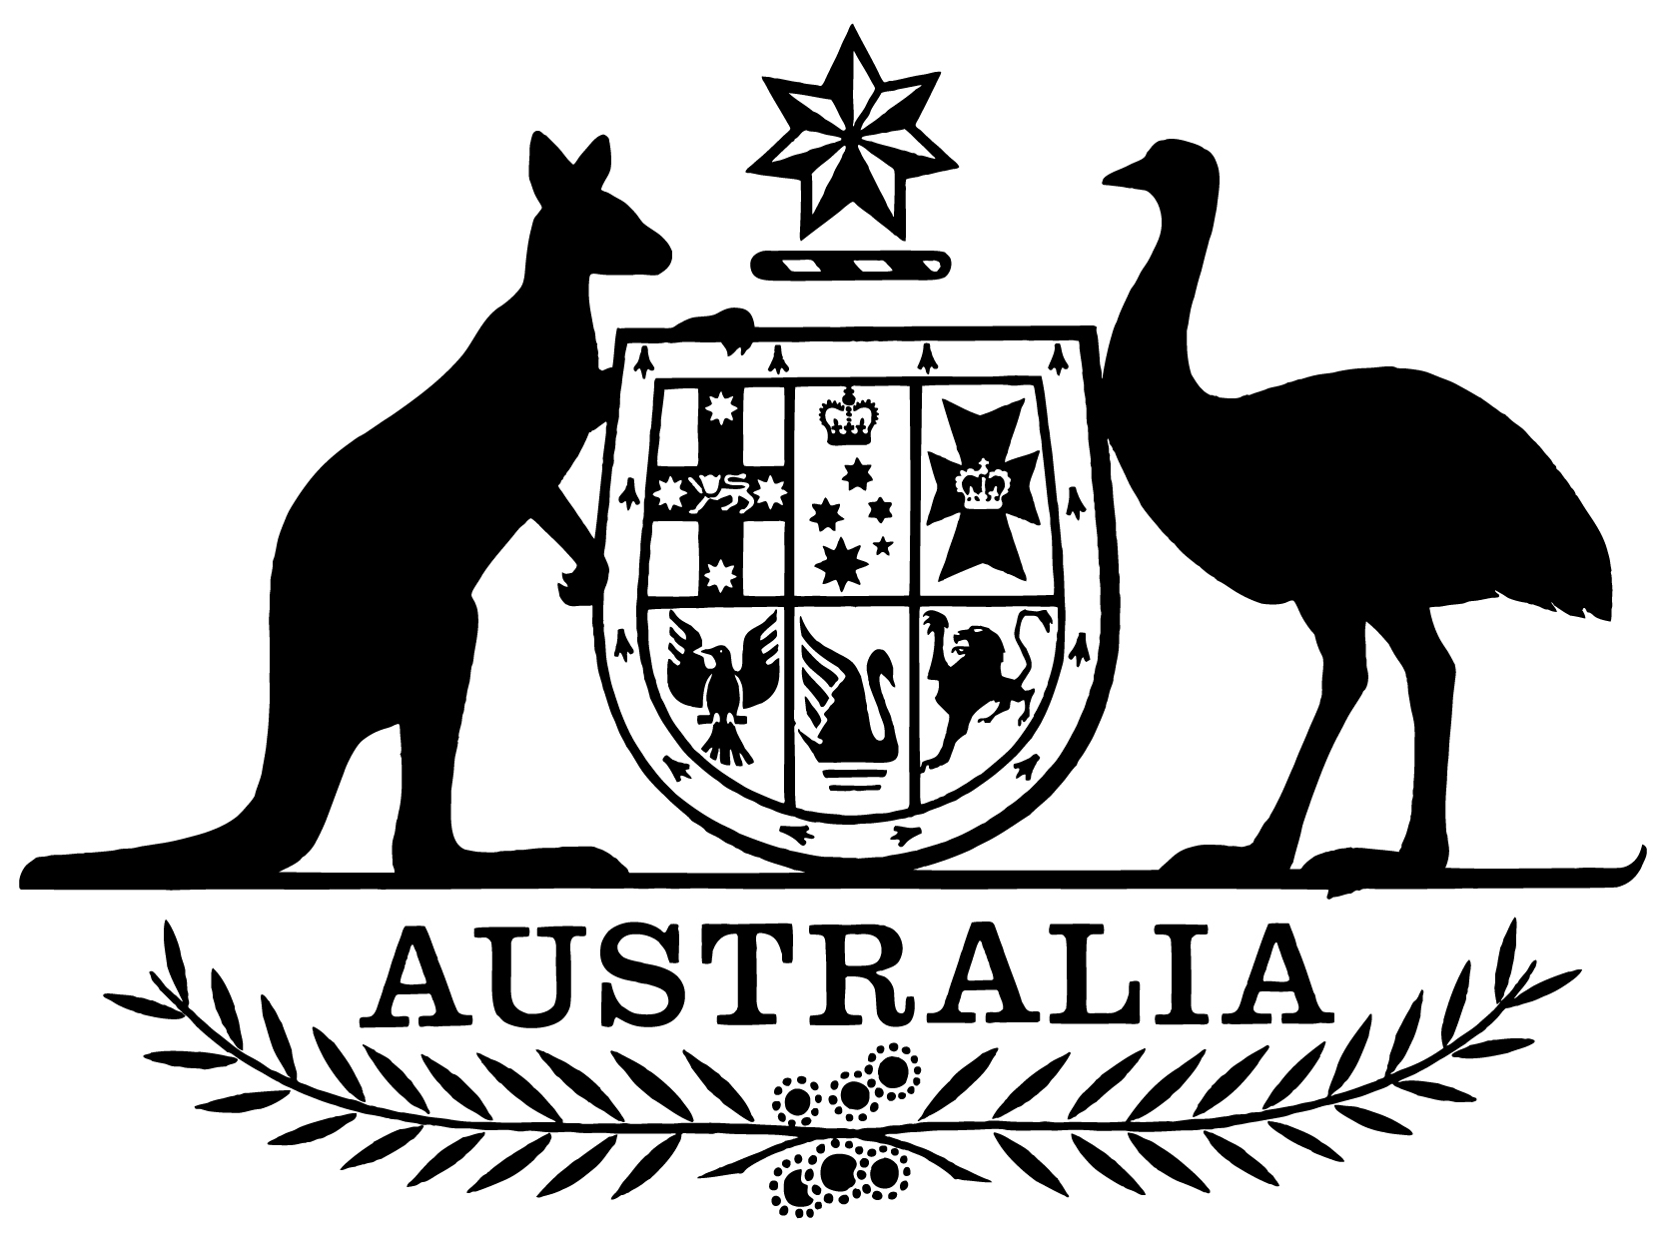

Statement of Expectations for the Board of the Civil Aviation Safety Authority for the Period 1 July 2019 to 30 June 2021

I, Michael McCormack, Minister for Infrastructure, Transport and Regional Development, make the following instrument.
Dated June 2019

Michael McCormack
Minister for Infrastructure, Transport and Regional Development

- Overview
This instrument is the Statement of Expectations for the Board of the Civil Aviation Safety Authority for the Period 1 July 2019 to 30 June 2021.
This instrument commences on 1 July 2019 and expires on 30 June 2021.
This instrument puts in place a new Statement of Expectations (SOE) which serves as a notice to the Board of the Civil Aviation Safety Authority (CASA) under section 12A of the Civil Aviation Act 1988 (the Act).
This new SOE formalises the Government’s expectations concerning the operations and performance of CASA.
CASA should perform its functions in accordance with the Act, the Airspace Act 2007 and the Public Governance, Performance and Accountability Act 2013 (PGPA Act) as well as other relevant legislation.
I also expect that the conduct and values of CASA’s Board and staff should be consistent with that of the Australian Public Service.

- Governance
I expect that the Board and the Director of Aviation Safety (DAS) will continue to work to enable the effective operation of CASA as the national aviation safety regulator.
I expect CASA to be a world-best-practice aviation safety regulator.
I expect the Board be responsible for the matters set out in the Act, including in particular, CASA’s strategic direction, risk management and corporate planning.
I expect the Board to ensure that CASA makes progress on its strategic priorities, including the key aviation initiatives outlined in this statement.
I also expect the Board to continue to facilitate effective interaction between CASA and industry.
Subject to the Act, I expect the DAS, as the Chief Executive Officer of CASA, to continue to be responsible for managing the operations of CASA, its organisational capacity, and the exercise of its statutory functions. This includes the development and implementation of regulation, executive-decision making, and all day-to-day operational, financial, personnel and administrative activities.
I expect the Board to keep me the Secretary of my Department fully informed of CASA’s actions in relation to the requirements stated in this SOE, and promptly advise of any events or issues that may impact on the operations of CASA, including through quarterly progress reports from the Board against the Corporate Plan and this SOE.

- Regulatory Approach
I expect CASA will continue its regulatory approach, in accordance with its regulatory philosophy, with:
(a) a focus on aviation safety as the highest priority;
(b) consideration of the economic and cost impact on individuals, businesses and the community in the development and finalisation of new or amended regulatory changes; and
(c) a pragmatic, practical and proportionate approach to regulation as it applies to different industry sectors.

- Key Aviation Initiatives
I expect CASA, in conducting its responsibilities as the aviation safety regulator, will focus on the following key aviation initiatives:
- finalise the remaining new Civil Aviation Safety Regulations and ensure effective implementation and transition arrangements are applied.
- continue effective engagement with industry in the lead up to the implementation of the flight operations suite of regulations, including on the issue of passenger limitations under Part 135 and on the development of associated regulatory and guidance material.
- support Airservices Australia in the implementation of the new civil-military air traffic management system, also known as OneSKY, with timely approval and certification activities, in addition to the continuing regulatory oversight of Australia’s existing air traffic management system.
- continue to respond to emerging risks related to drones, including the implementation of a registration and accreditation scheme and working collaboratively with my Department and Airservices Australia on an approach to the safe and efficient airspace integration of unmanned vehicle that complements the Government’s broader approach to this sector.
- provide regulatory oversight for major aerodrome infrastructure projects, including Western Sydney Airport and significant new runway projects, as well as providing authoritative and timely advice to me and my Department on other airport developments, to assist me in complying with the statutory requirements of the Airports Act 1996, and regulations made under it.
- work with my Department and Airservices Australia on modernising airspace management, including, as the regulator, leading the development of a national strategic airspace plan which articulates a regulatory narrative on controlled airspace.
- work with Geoscience Australia and Airservices Australia to progress safe and timely implementation of satellite based augmentation systems in the air traffic management environment.
- assist with the Australian Space Agency in forming their regulatory framework for high powered rockets and provide timely approvals and advice for operation under their regulations to ensure safe integrations into the air traffic management environment.
- continue to share safety information consistently with the Safety Information Policy Statement agreed with the Australian Transport Safety Bureau.
- maintain international and regional aviation safety engagement through effective engagement in the International Civil Aviation Organization (ICAO) and strategic support of aviation safety initiatives in the Asia-Pacific region.
- continue to ensure CASA’s training and recruitment strategies provide the organisation with the skills and expertise to meet the current and emerging challenges in aviation safety regulation.

- Stakeholder Engagement
I expect CASA will continue to:
- undertake effective and ongoing engagement with the aviation industry to create a collaborative relationship based on a foundation of mutual understanding and respect.
- communicate clearly and regularly with relevant Government agencies, industry and other key stakeholders regarding CASA’s activities and functions.
- work closely with my Department and other Government agencies, including the Australian Transport Safety Bureau, Airservices Australia and the Department of Defence, to deliver integrated and comprehensive safety advice to the Government, the aviation industry and the community.

