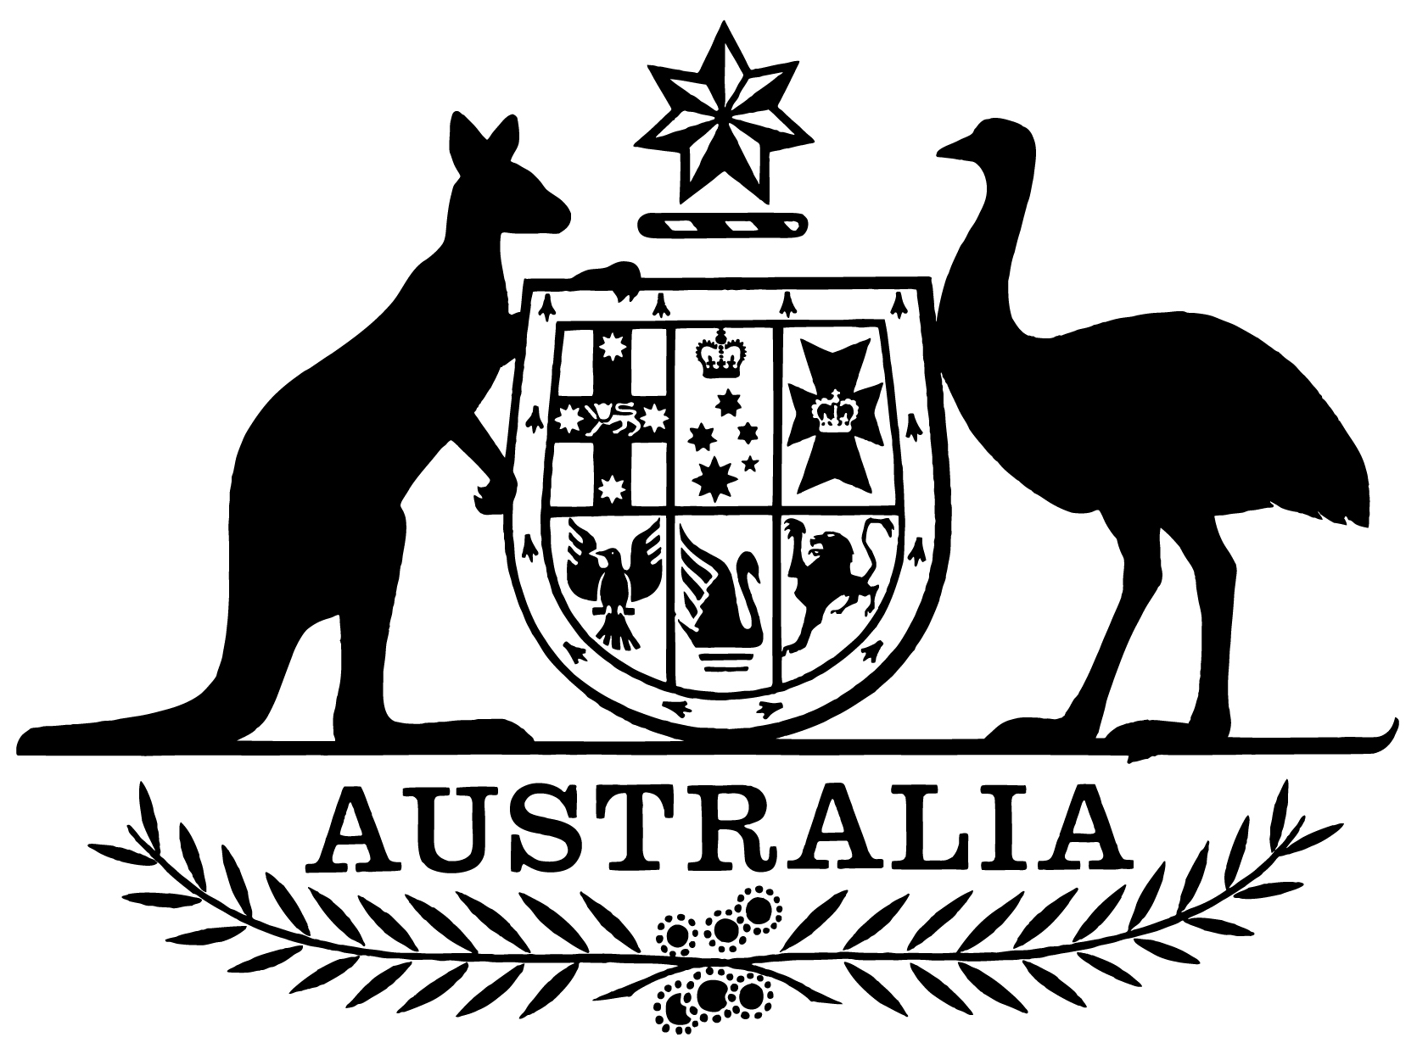

Statement of Expectations for Airservices Australia for the Period 1 July 2019 to 30 June 2021

I, Michael McCormack, Minister for Infrastructure, Transport and Regional Development, make the following instrument.
Dated June 2019

Michael McCormack
Minister for Infrastructure, Transport and Regional Development

- Overview
This instrument is the Statement of Expectations for Airservices Australia for the Period 1 July 2019 to 30 June 2021.
This instrument commences on 1 July 2019 and expires on 30 June 2021.
This instrument puts in place a new Statement of Expectations (SOE) which serves as a notice to Airservices Australia (Airservices) under section 17 of the Air Services Act 1995 (the Act).
The new SOE formalises the Government’s expectations concerning the operations and performance of Airservices.
Airservices should perform its functions in accordance with the Act, which requires that Airservices must regard the safety of air navigation as the most important consideration.
Airservices should also perform its functions in accordance with the Public Governance, Performance and Accountability Act 2013 (PGPA Act) as well as other relevant legislation.

- Governance
I expect that the Board and the Chief Executive Officer (CEO) will continue to work to enable Airservices to operate as a world-best-practice Air Traffic Control (ATC) and Aviation Rescue and Fire Fighting Service (ARFFS) provider.
I expect the Board to ensure Airservices has the necessary resources and capabilities in place to effectively manage Airservices’ strategic direction, risks and corporate planning.
I expect the CEO to be responsible for managing the operations of Airservices, its organisational capacity and the exercise of its functions.
I expect the Board to keep the Secretary of my Department and me fully informed of Airservices’ actions in relation to the requirements stated in this SOE, and promptly advise of any events or issues that may impact on the operations of Airservices, including through quarterly progress reports from the Board against the Corporate Plan and this SOE.

- Key Aviation Initiatives
I expect Airservices, in conducting its responsibilities as the air navigation and aviation rescue and fire fighting services provider, will focus on the following key aviation initiatives:
- progress the timely, on-budget and effective implementation of the civil-military air traffic management program, known as OneSKY, including harmonisation initiatives with the Department of Defence (Defence) and advise me on the progress and achievement of program milestones.
- work closely with my Department and the Civil Aviation Safety Authority (CASA) to ensure the safe integration of Unmanned Aircraft Systems (UAS) into Australian airspace, including the development and implementation of a UAS traffic management system that complements the Government’s broader approach to this sector.
- work with my Department and CASA on modernising airspace management, including
  - progressing Australia’s airspace protection policy;
  - enhancing the safety and efficiency of Australian controlled airspace including at major regional airports;
  - continuing to apply adequate resources to manage airspace planning and design including for Western Sydney Airport; and
- continuing the implementation of Performance Based Navigation in Australia following consultation with other Government agencies, community and industry stakeholders.
- assist in implementing the Government’s environmental initiatives including:
- minimising the impact of aircraft operations on communities where practicable;
- supporting the ongoing role of the independent Aircraft Noise Ombudsman (ANO) and implementation of agreed recommendations made by the ANO;
- appropriate resourcing of the Noise Complaints and Information Service to continue to improve the flow and quality of information to noise affected communities;
- ongoing commitment to the Sydney Airport Long Term Operating Plan as required by the Ministerial direction dated 30 July 1997 (F2009B00158);
- providing and reporting against an annual environment work program which outlines Airservices ongoing and new initiatives in managing, monitoring and alleviating, where safe and practicable, environmental effects of aircraft operations; and
- working with the Department and industry on issues related to environmental contamination, including per- and poly-fluoroalkyl substances (PFAS) in line with Government expectations on this issue.
- continue to work with the Department and CASA on implementing the Government’s ARFFS policy.
- maintain international and regional aviation safety engagement through effective engagement in the International Civil Aviation Organization (ICAO) and safety and capability building initiatives in the Asia-Pacific region.

Stakeholder Engagement
I expect Airservices will continue to:
- undertake effective and productive engagement with the community and industry based on mutual understanding and respect.
- communicate clearly and regularly with my Department and CASA, industry and the community on the development and implementation of significant changes to air navigation and ARFFS.
- proactively provide information, assistance and advice to Government agencies for policy formulation, implementation activities and regulation purposes.
- contribute in the coordinated approach to airport planning including appropriate participation in planning coordination forums, community aviation consultation groups, and the National Airports Safeguarding Advisory Group.
- work closely with my Department and other Government agencies, including the Australian Transport Safety Bureau, CASA and Defence to deliver integrated and comprehensive advice to the Government, the aviation industry and the community.

